**CS6PO5 FINAL YEAR PROJECT**



**Module Code & Module Title**



**Assessment Weightage & Type**

**5% FYP Proposal**

**Year and Semester**

**2020-21 Autumn**

#### Student Name: Kamlesh Kumar Singh

#### Group: C14

**London Met ID: 18030853**

**College ID: NP01CP4S190073**

**SUPERVISOR**

#### External Supervisor: Yunisha Bajracharya

#### Internal Supervisor: Hitesh Shrestha

*I confirm that I understand my coursework needs to be submitted online via Google Classroom under the relevant module page before the deadline in order for my assignment to be accepted and marked. I am fully aware that late submissions will be treated as non-submission and a marks of zero will be awarded.*

**Table of Contents**

1. Introduction: 4

1.1 Admin Module:- 4

1.2 Staff Module:- 5

Features of Staff module 5

1.3 Fee Module:- 5

Features of Fee module 5

A. Problems scenario: 5

B. The project as a solution: 6

2. Aims and Objectives: 6

2.1 Aims 6

2.2 Objectives 6

3. Expected outcomes and deliverables: 7

4. Project risks, threats and contingency plans: 7

4.1 Contingency plan: 7

5. Methodology: 8

5.1 Dynamic Systems Development Method (DSDM) 8

6. Resources requirements: 10

6.1 Hardware requirement 10

6.2 Software requirement 10

6.3 Framework 10

6.4 Front End 10

6.5 BackEnd 10

6.6 IDE 10

7. Work breakdown structure: 11

8. Milestones: 12

9. Gantt chart. 13

10. Conclusion: 14

Bibliography 14

**List of Figures**

Figure 1: DSDM Methodology. 9

Figure 2: Work breakdown Structure. 11

Figure 3: Milestone diagram. 12

Figure 4: Gantt-Chart. 13

# 1. Introduction:

Education system is the backbone of every country. It is importance to provide the good educational foundation to the young generation to secure the future for everyone. School authorities all over the world are engaged in a lot of day-to-day administrative and academic activities to manage and provide a better academic experience to students effectively (MINDSTER, 2019). The topic of the project is “School Management System”, which is web based application. This application is used to design to manage the school. This web application is very helpful to accounts department in manage the details to the fee and basic details. Which is also help for administration department in maintain the students, staffs details as well as keeping a checking the fees details. This web application is basically developed for the authorities of the school to make their task easier. It provides the facilities to keep the records of student fee, teacher and their staff. This web application is vital rules of run smooth of school. Which help the admin and teachers and their staffs. In the school is the large number of the database which is difficult of managing in the daily work.

## 1.1 Admin Module:-

#### Features of Admin module

* User Create
* Add Staff
* View Reports

## 1.2 Staff Module:-

## Features of Staff module

* User Create
* Add Students
* View Reports

## 1.3 Fee Module:-

## Features of Fee module

* Fee Rate & Columns Setup
* Fee Collection
* View Reports

### Problems scenario:

In this school, it’s difficult to manage records for students as well as teachers. No any person can manage all records in manual books or files. When the student fill the admission form and Staff Registration form by use the manual system, in this case data loss in the several problems is occurs. And the many problem that can be happen to search the data of the student.so that have no any systematic record.

Bookkeeping system is not providing the Security of the academic information that might be lost. Book keeping system was not efficient. And large number of the man power are required to maintain the data of the student and the free structure of the student. In the accounts section some time there is not accurate calculation in the fee structure. Bookkeeping system is not suitable for exchange the electronic data.

### B. The project as a solution:

The solution of all the project was to automatic or computerized system. Which helps to maintain the records of the students and theirs fee structure. Which helps to accurate in fee structure. And reduces the man power. This is suitable for exchange the electronic data. Managing a high school and bringing together departments and campuses to achieve the mission is always a big challenge for school management. Transforming schools system with high technology-enabled automation tools to support the academic and administrative processes will make it easy to achieve their goals (Sriram, 2019). There is not manual system which is very easy to search the student details. The student’s data maintenance would to reduce the manpower. This web application is very helpful of the school management system.

# 2. Aims and Objectives:

## 2.1 Aims

The main aims of the project is to computerized the manual system for the school and their details of the students forms, staff registration form and their free Rate setup of the student. Which is very helpful for account department and reduce the time consumption.

.

## 2.2 Objectives

The objectives of this project are:

* Its makes all the system are computerized.
* It reduces the time utilization.
* There is No paper work requirement.
* This very easy to operations for operator of the system.
* The main of accuracy of the account dependents.
* It reduce the main power.

# 3. Expected outcomes and deliverables:

After the successfully development of the application, it will be able to perform following tasks:-

* Admin user can create new user.
* Admin user can view records for students, teachers, and other users.
* Admin user can setup fee records and fee structure.
* Admin user can access to all over system.
* Staff user can create new, modify, and delete records for students.
* Staff user can view reports for students and other staffs.
* Staff user can collect fees from students.
* Staffs can view their log

# 4. Project risks, threats and contingency plans:

* Records management should be done properly otherwise proper information may not be stored in database.
* This system is not connected to attendance system, so records related to staffs & student’s presence cannot be known by this system.
* Billing records should be done properly otherwise, Student Fee collection report may not be shown properly.

## 4.1 Contingency plan:

* Trying to complete project in time.
* Research about web-application and web sites.

# 5. Methodology:

## 5.1 Dynamic Systems Development Method (DSDM)

Dynamic systems development method (DSDM) is an agile project delivery framework, initially used as a software development method. First released in 1994, DSDM originally sought to provide some discipline to the rapid application development (RAD) method. In later versions, the DSDM Agile Project Framework was revised and became a generic approach to project management and solution delivery rather than being focused specifically on software development and code creation and could be used for non-IT projects. The DSDM Agile Project Framework covers a wide range of activities across the whole project lifecycle and includes strong foundations and governance, which set it apart from some other Agile methods (Zaabab, 2018).

DSDM fixes cost, quality and time at the outset and uses the MoSCoW prioritization of scope into musts, should, could and won't haves to adjust the project deliverable to meet the stated time constraint. DSDM is one of a number of Agile methods for developing software and non-IT solutions, and it forms a part of the Agile Alliance. In 2014, DSDM released the latest version of the method in the 'DSDM Agile Project Framework'. At the same time the new DSDM manual recognized the need to operate alongside other frameworks for service delivery (esp. ITIL) PRINCE2, Managing Successful Programs, and PMI. The previous version (DSDM 4.2) had only contained guidance on how to use DSDM with Extreme Programming (Zaabab, 2018).

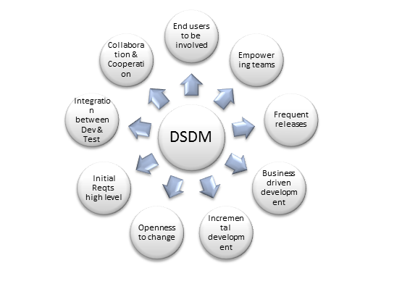

(Gupta, n.d.)

Figure 1: DSDM Methodology.

# 6. Resources requirements:

## 6.1 Hardware requirement

#### ➢ Pc with windows 10

## 6.2 Software requirement

#### C# .Net MVC

* **SQL Server**
* **OS windows Server**

## 6.3 Framework

#### ➢.Net 4.6

## 6.4 Front End

#### ➢ Drag and drop

## 6.5 BackEnd

#### ➢ MS SQL Server 2012

## 6.6 IDE

#### ➢ Visual Studio 2017

# 7. Work breakdown structure:

The figure of work breakdown structure:

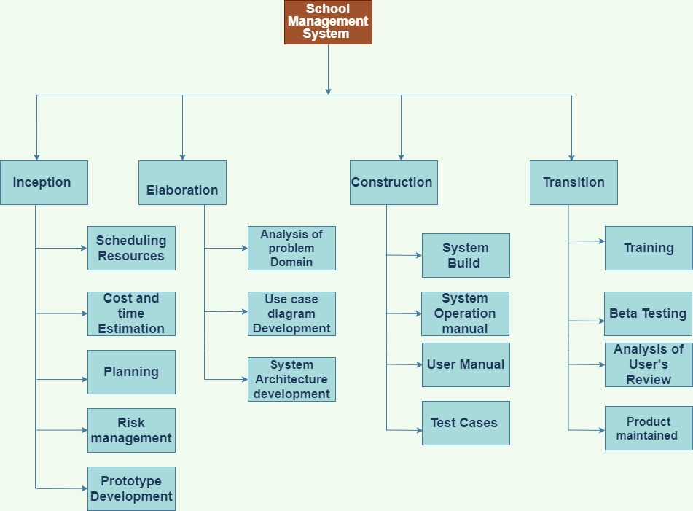

Figure 2: Work breakdown Structure.

# 8. Milestones:

A project milestone is a management tool that is used to delineate a point in a project schedule. These points can note the start and finish of a project, and mark the completion of a major phase of work. Milestones can be used to symbolize anything that has started or finished, though it’s primarily used as a [scheduling tool](https://www.projectmanager.com/software/scheduling) (Westland, 2020). The figures of milestones is shown below:

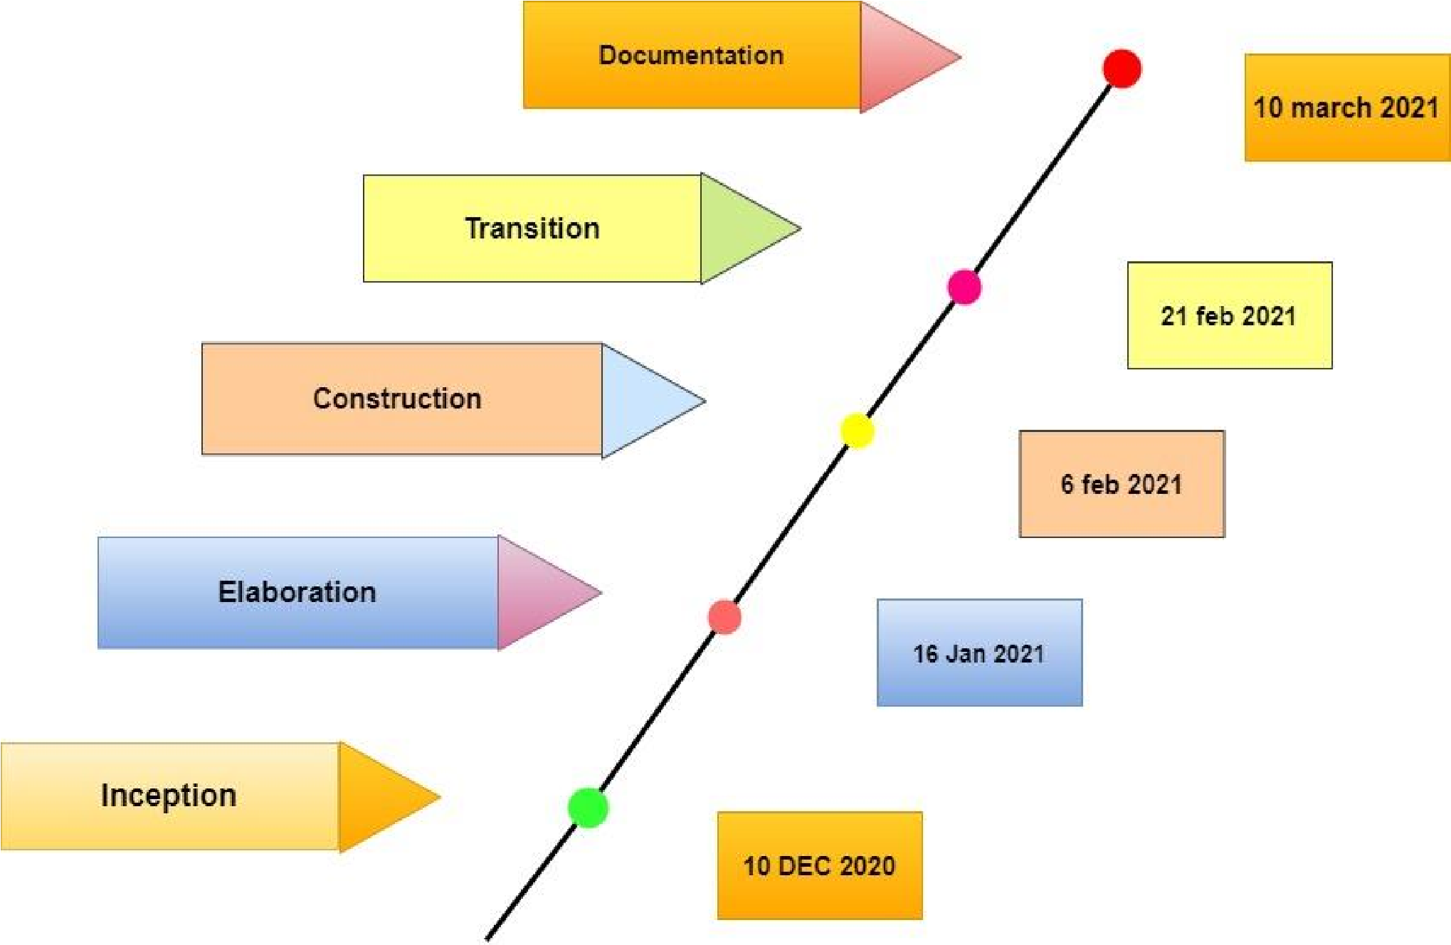

Figure 3: Milestone diagram.

# 9. Gantt chart.

**A Gantt chart is a timeline of a project.**The top of the chart shows the time frame and the left side of the chart lists the project activities. Gantt charts can be a helpful visual to include in [project management plans](https://venngage.com/blog/project-management-plan/). Like the previous example, this retro daily project Gantt chart example breaks down project activities day by day (KIENAPPLE, 2019). The figures of Gantt-Chart is shown below:

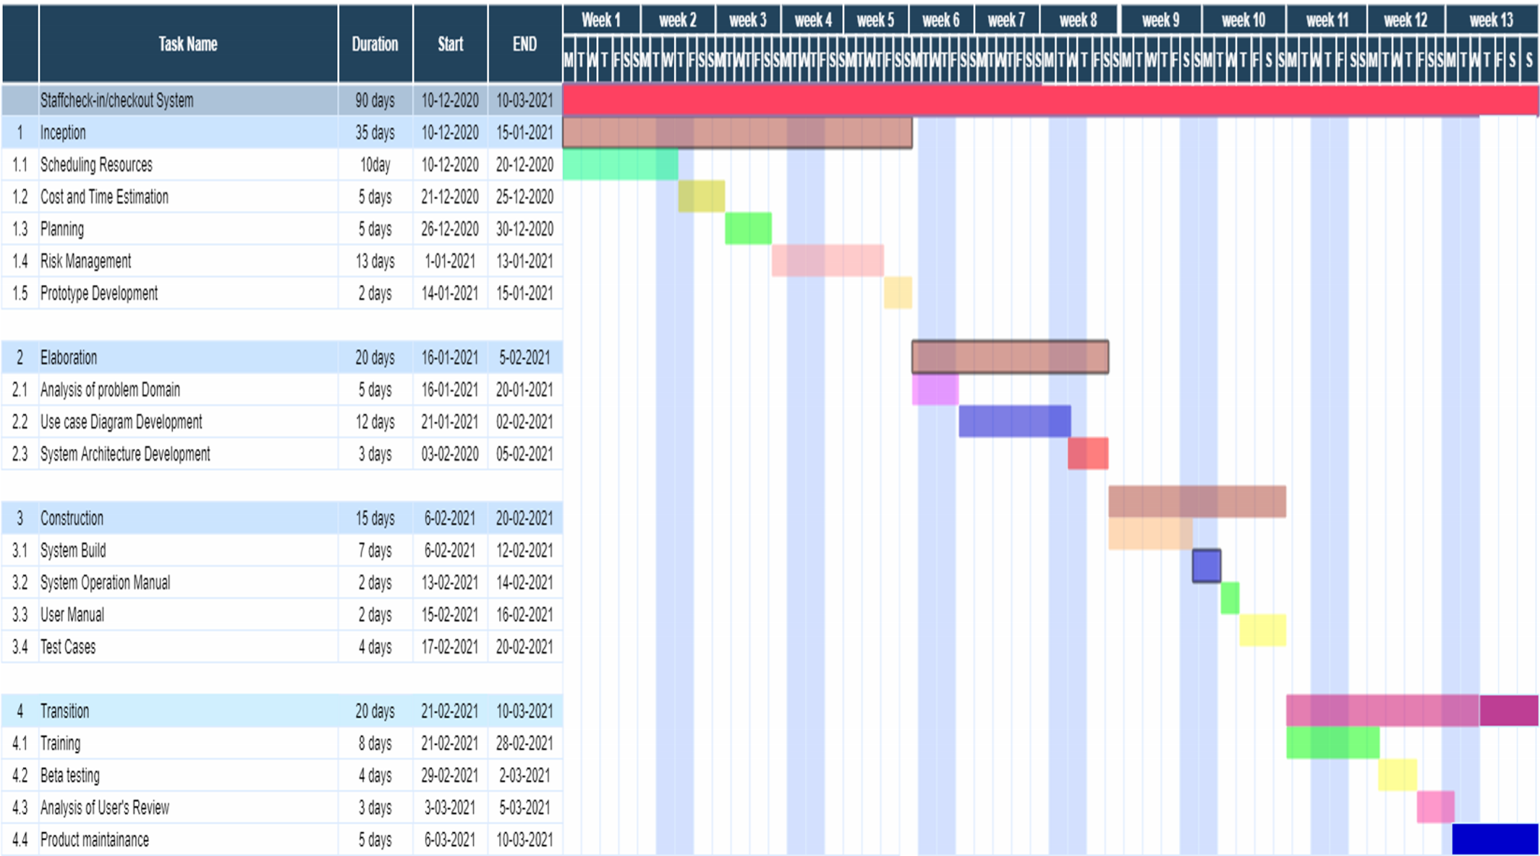

Figure 4: Gantt-Chart.

# 10. Conclusion:

This project is helps to staff and administration for see the details of the student and fee collection reports. Which is very helpful to perform paperless work and manage the data of the student. It provides easy to accurate the fee details. Which student fee generated reports and fee collection of the student. And also the management system software offers the feature for a finance department. This helps the administrative staff to save their labor and time. And many time available to focus on another priority task.

To complete this proposal lots of research of the books, websites, journals etc. and dedication will be done in a stepwise to complete whole school management system.in this project the knowledge and experienced gained from this project will help to improve much more my skills.

# Bibliography

Gupta, S. (n.d.). *9 Principles (building blocks) of DSDM – AGILE*. Retrieved from quotium: http://www.quotium.com/performance/9-principles-building-blocks-dsdm-agile/

KIENAPPLE, B. (2019, Mar 25). *11 Gantt Chart Examples and Templates For Effective Project Management*. Retrieved Jun 6, 2020, from VENNGAGE: https://venngage.com/blog/gantt-chart-example/#2

MINDSTER. (2019, May 28). *what is a school management system? Why Institutes need it ?* Retrieved jun 5, 2021, from MINDSTER: https://mindster.com/what-school-management-system-why-institutes-need-it/#:~:text=Introduction%20of%20school%20management%20systems,SMS%20messages%20and%20live%20chats.&text=Parents%20can%20use%20the%20portal,messaging%2C%20voice%20chats%20or%20emails.

Sriram. (2019, May 14). *how to solve the problem of school management systmem.* Retrieved jun 5, 2021, from Creatrix Campus: https://www.creatrixcampus.com/blog/top-10-issues-around-school-management-and-how-solve-them-easily

Westland, J. (2020, Sep 23). *What Are Milestones in Project Management?* Retrieved jun 5, 2021, from ProjectManager: https://www.projectmanager.com/blog/milestones-project-management

Zaabab, F. (2018, Aug 12). *Project management system*. Retrieved jun 5, 2021, from Project management system.: https://www.projectmanagement.com/wikis/483410/DSDM--Dynamic-Systems-Development-Method-